Tbl_project

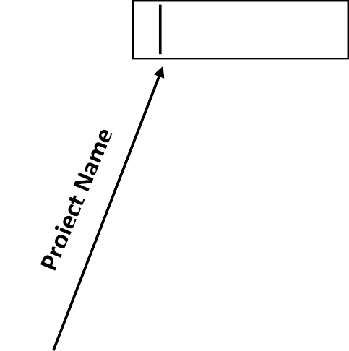

**USER**

Project name content

3.1

Home process

Returned project id

Created to that project

tbl_content